Notes & Note taking template
Course - Best Digital Technology Business Models Today
M4.1: Search & Transaction Cost

Overview
The saving of search, transaction and post-transaction cost in comparison to traditional business models is one of the most important concepts underpinning the success of platform business models.
Some professors state this to be in fact the most important aspect.
Going back to the 1937 work of the Nobel Prize-winning economist Ronald Coase, we will see how internalising transaction cost was an important contributor to firms and large firms emerging in the industrial areas.
Platform business models, however, have reversed this process of internalising such costs but externalising them back to the participants of the platform by bringing them down to acceptable levels, distributing them on many shoulders and rewarding their acceptance with new value propositions.
We will be using 4 major verticals to demonstrate their importance and understand similarities & differences: Assets & Service Sharing, Social & Communication, Search & Vertical Search and eCommerce.

Key Objectives
We will learn about the cost structures of tech companies:
- Some theoretical background on
  - Search,
  - transaction and
  - post-transaction cost
- Externalising internal (transaction) cost
- Examples from:
  - Assets & Service Sharing,
  - Social & Communication,
  - Search & Vertical Search and
  - eCommerce

Intro / Theory Video
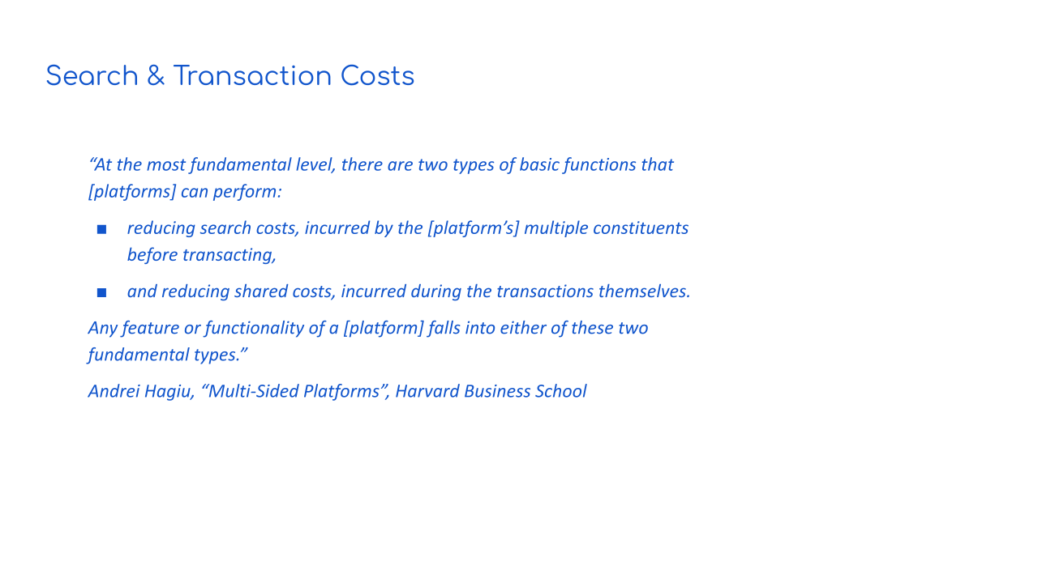

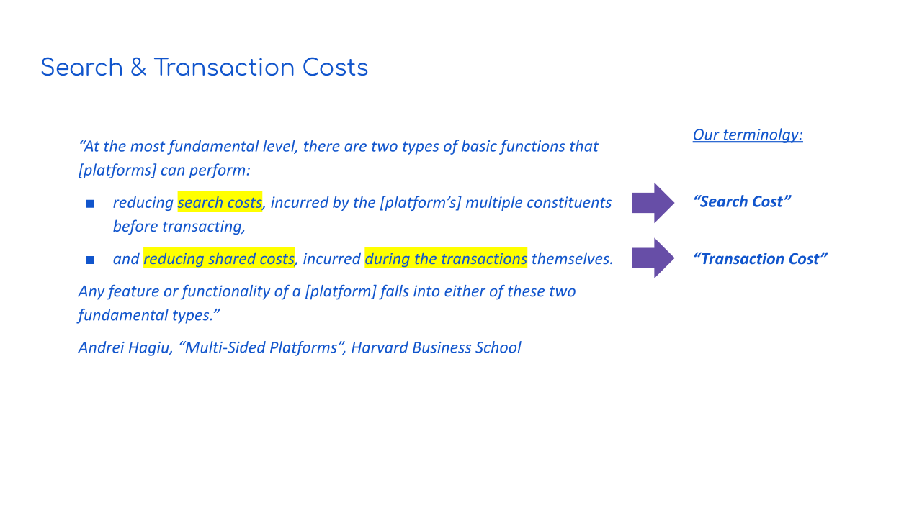

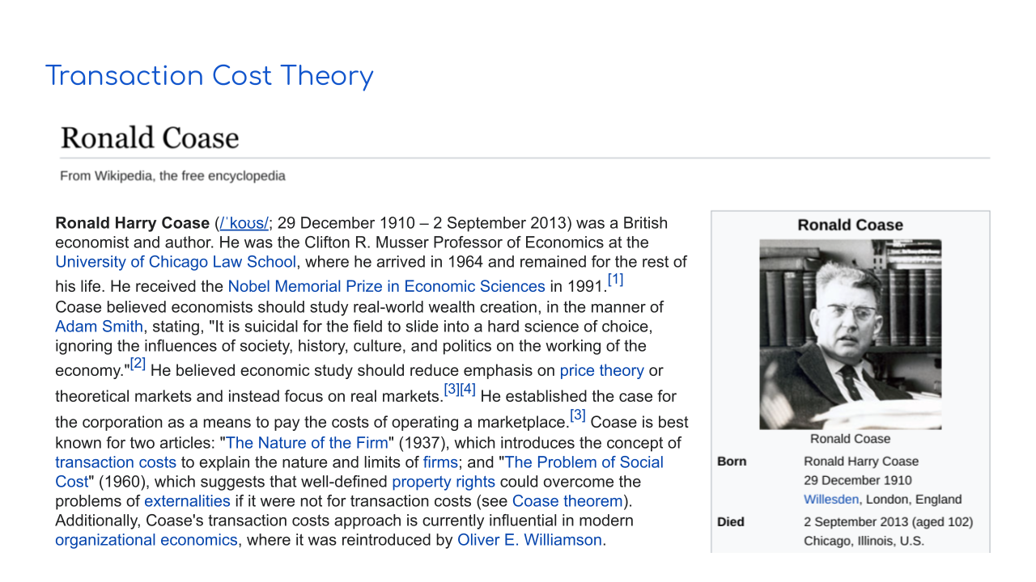

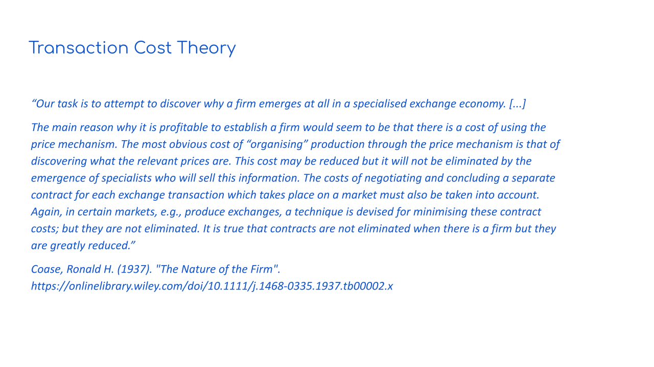

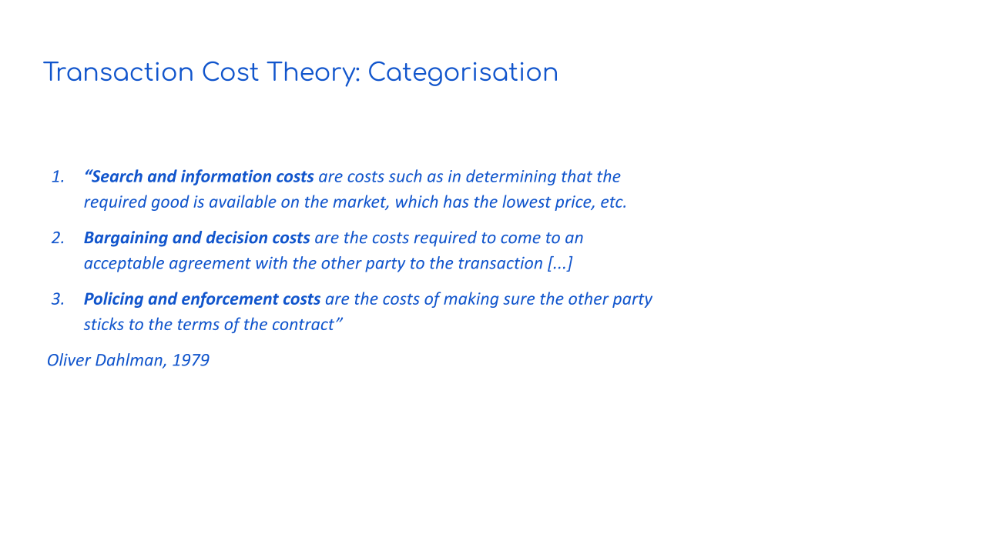

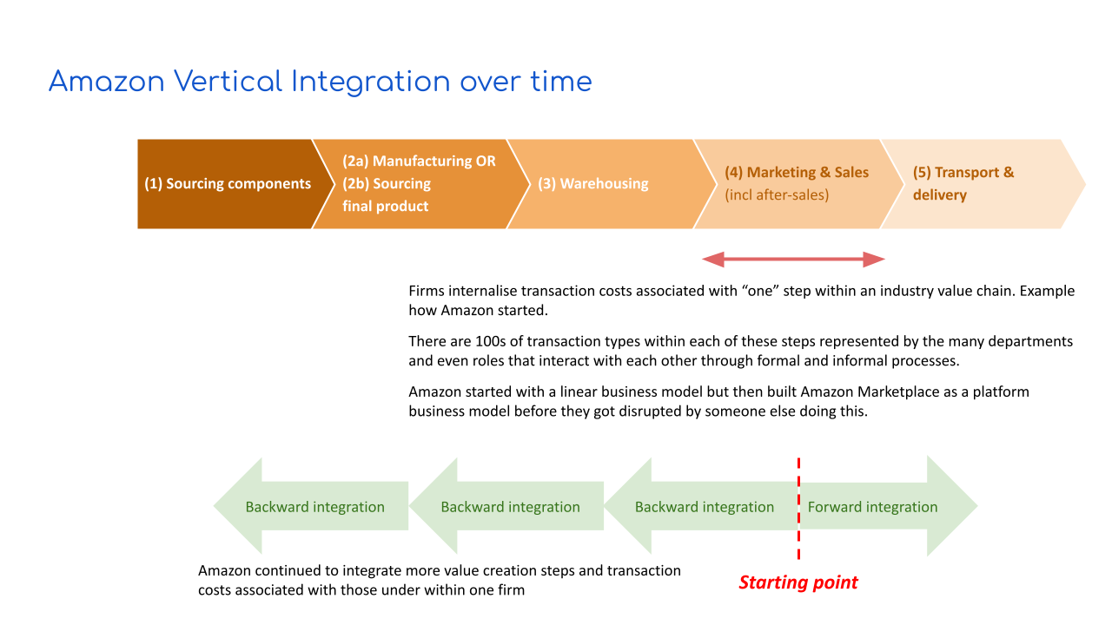

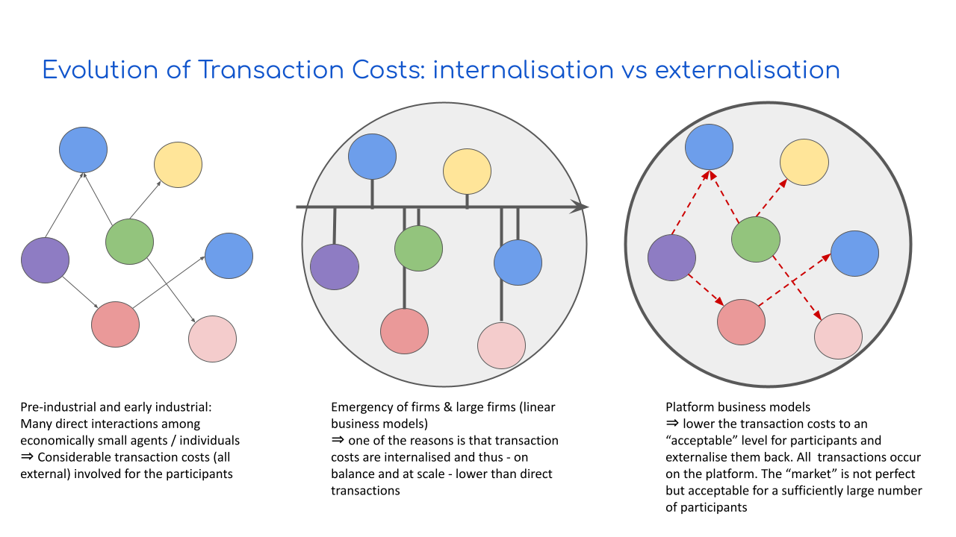

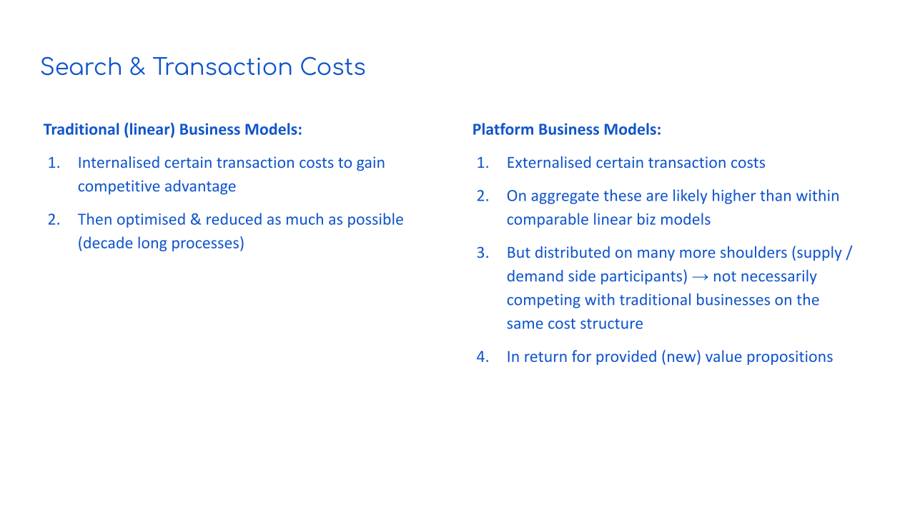

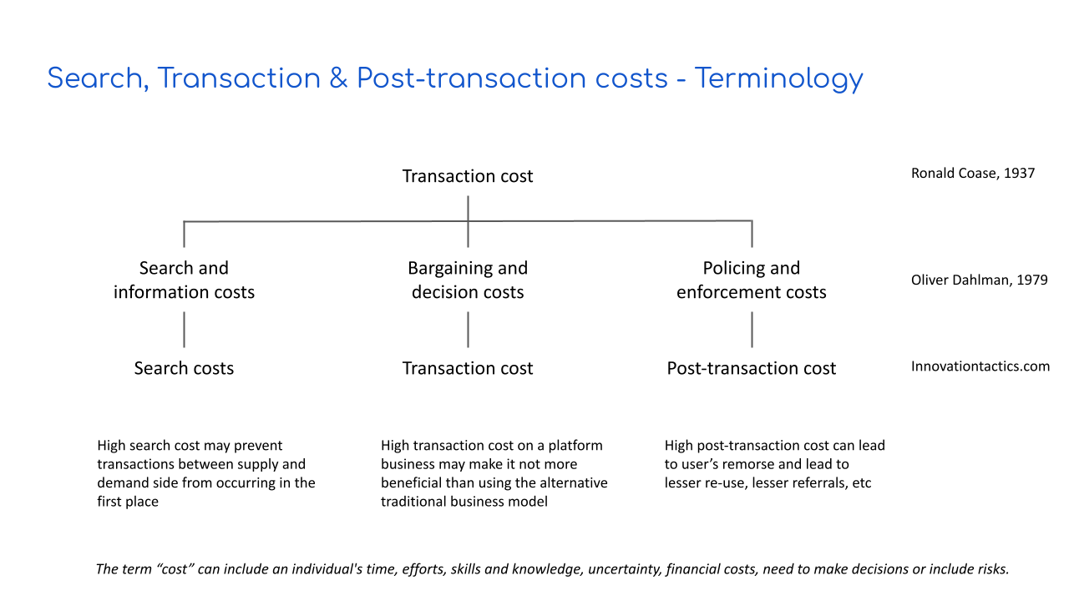

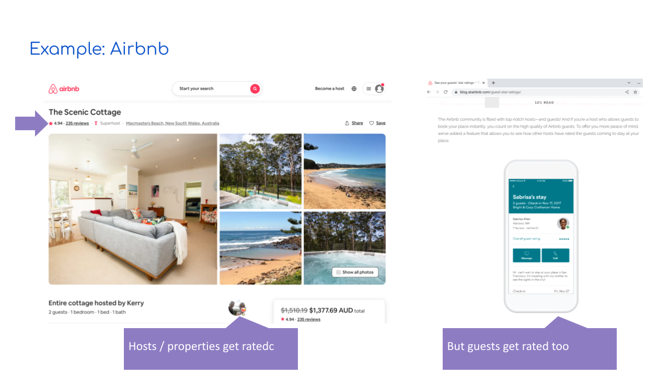

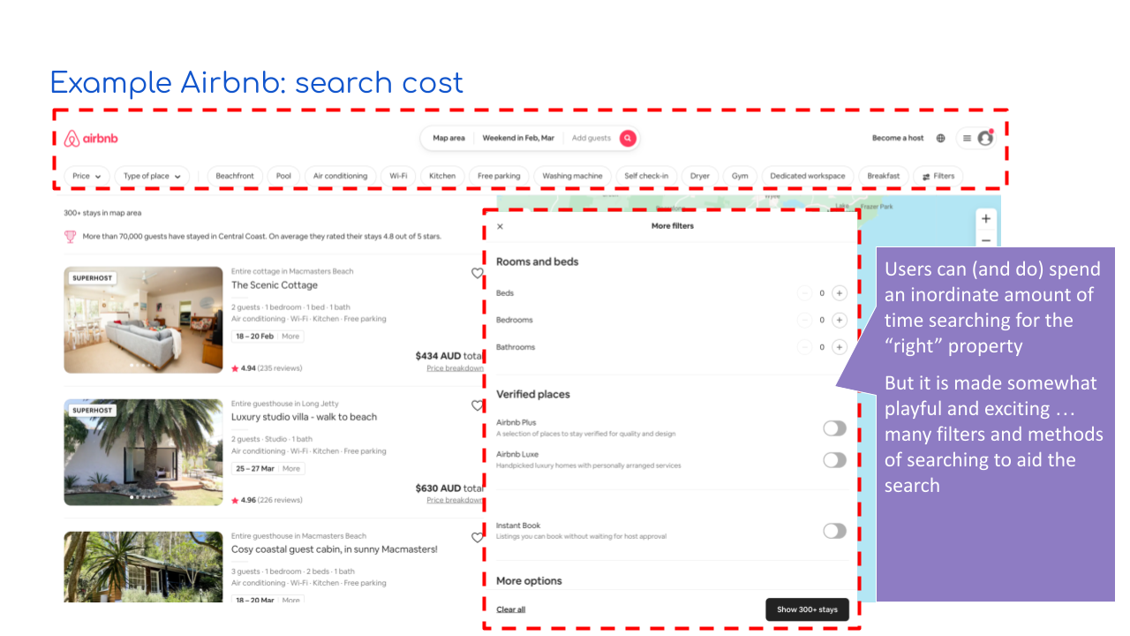

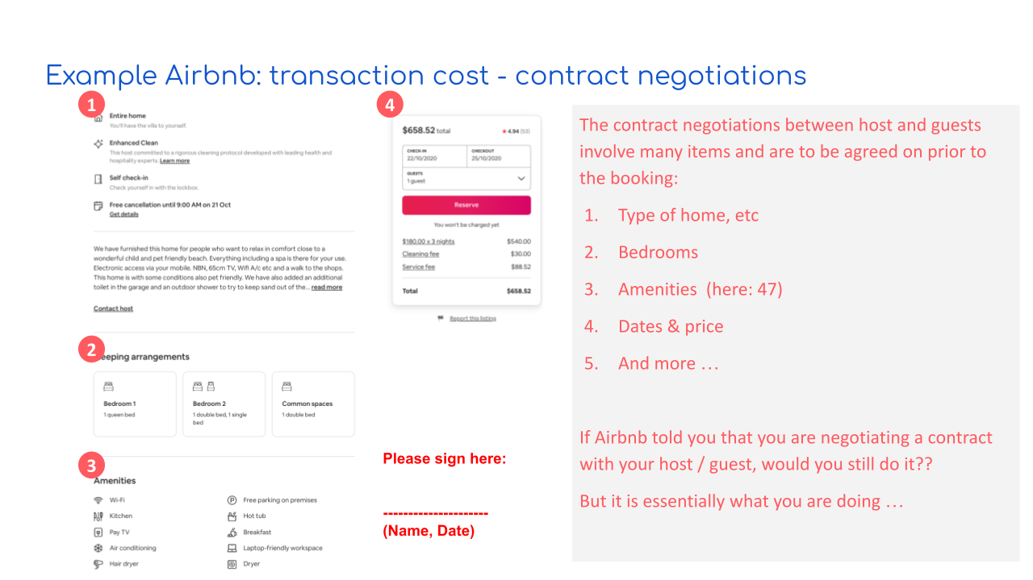

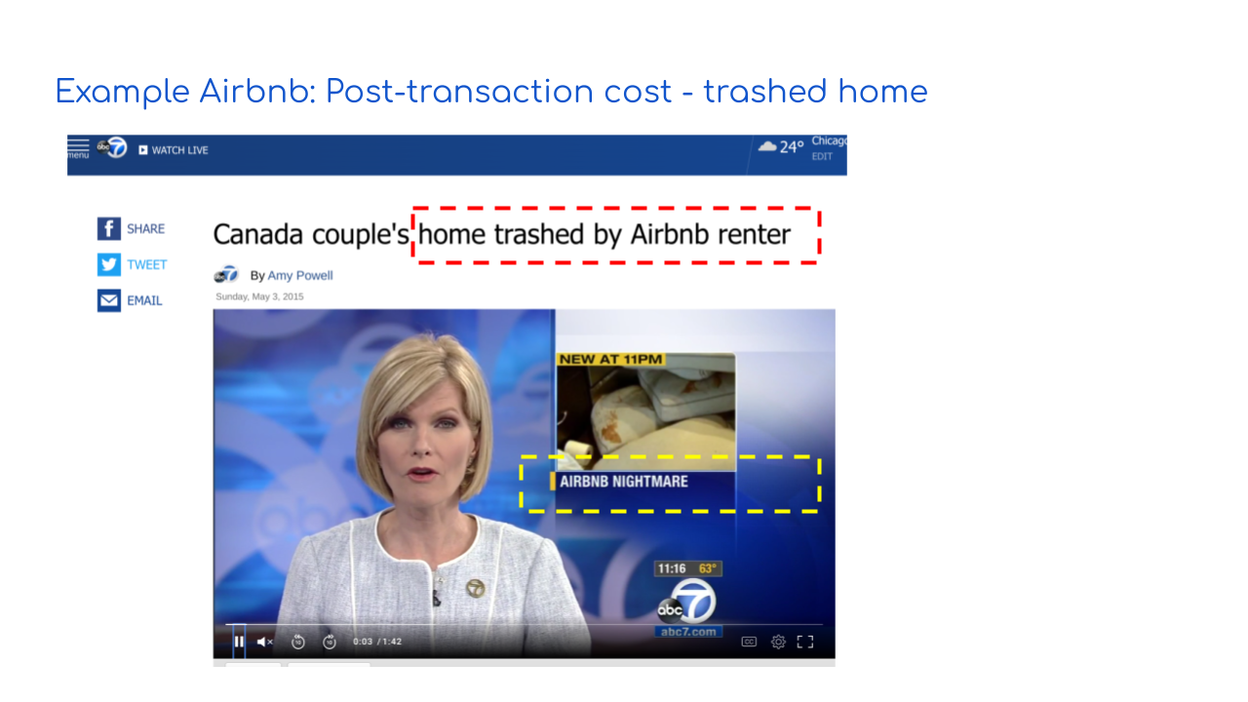

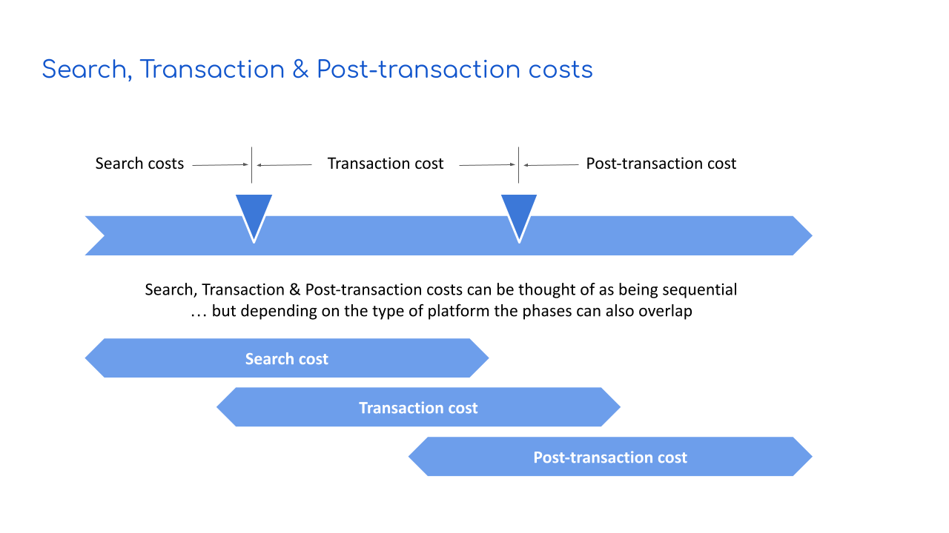

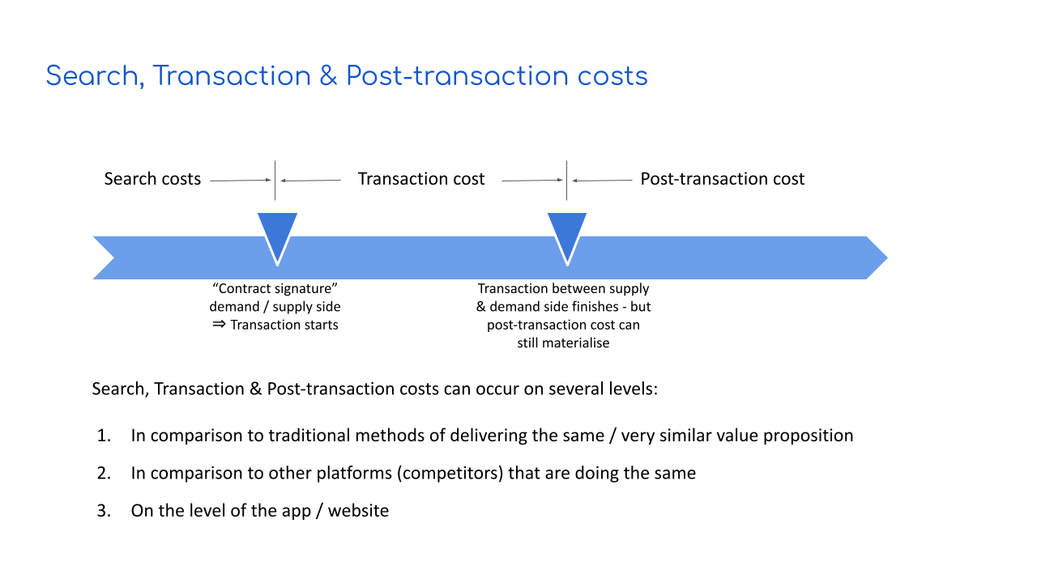

Examples / detailed resources

Resource 1: Search, transaction cost additional details

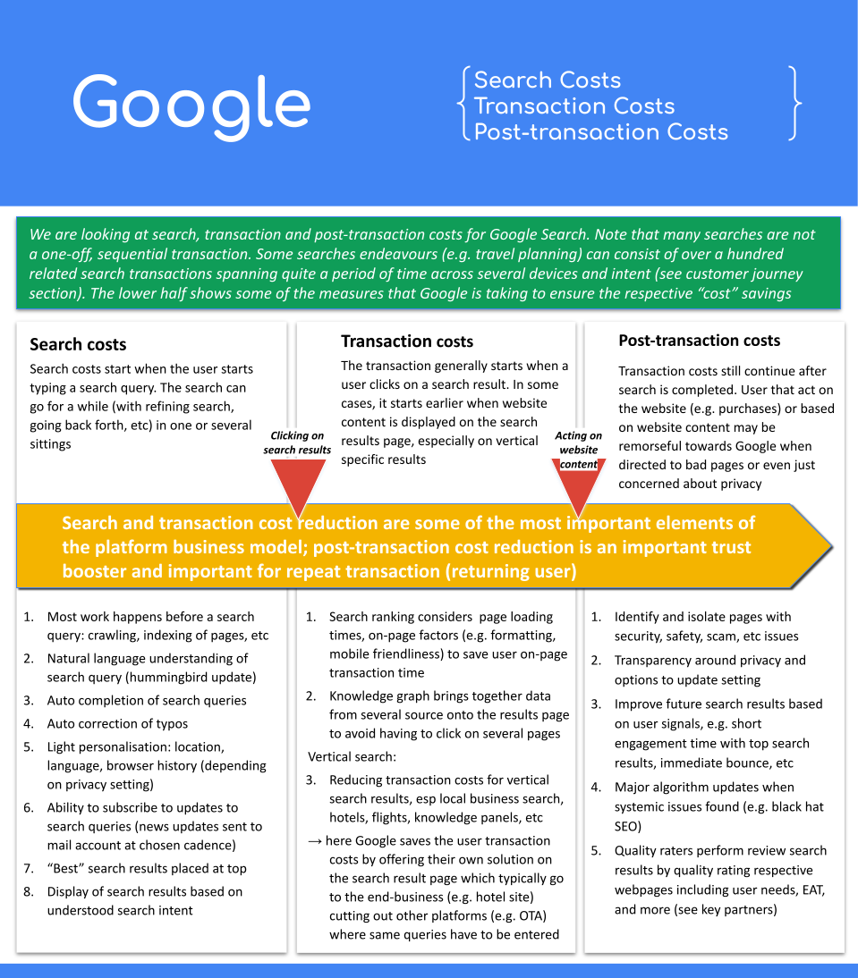
Your notes:
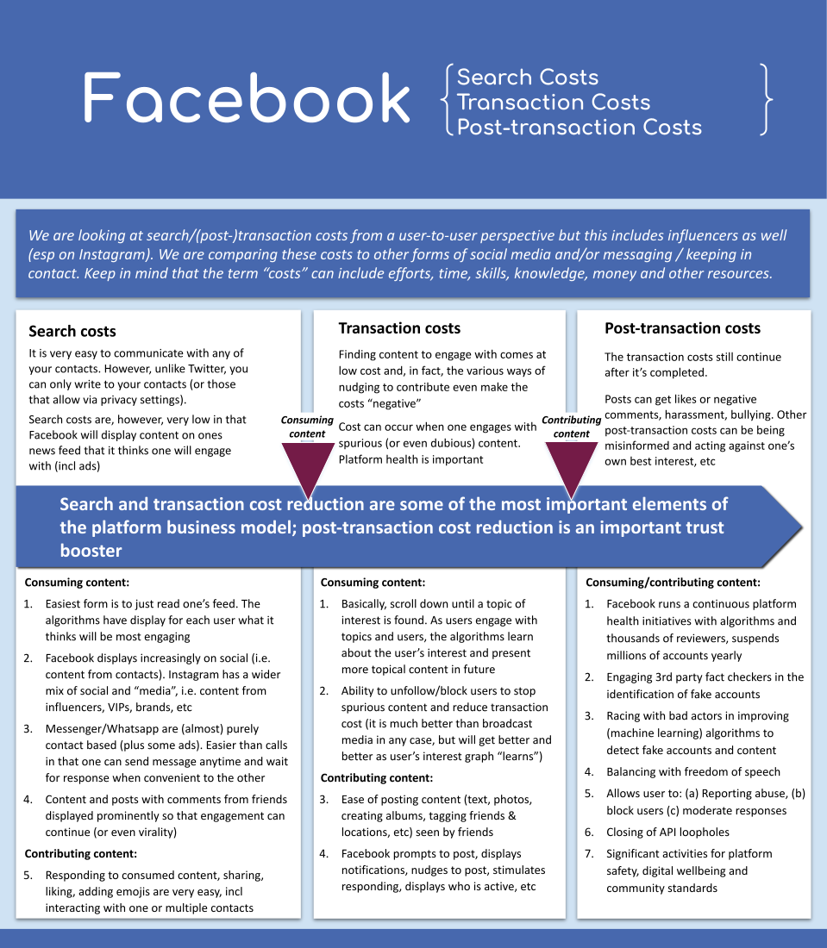

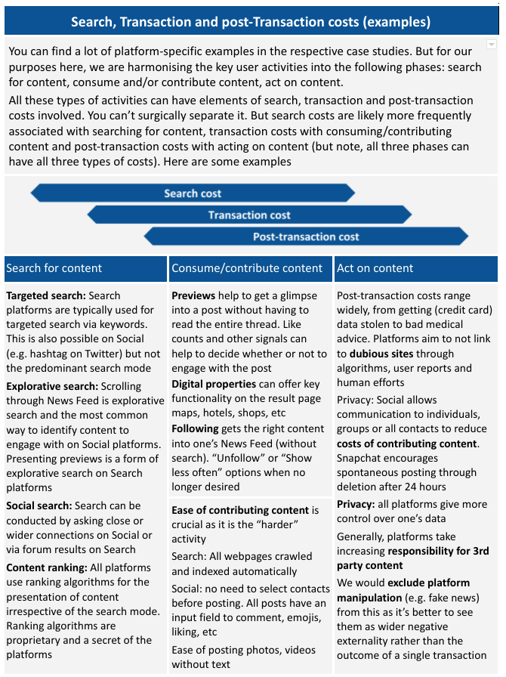

Resource 2: Common types of Search, Transaction cost savings

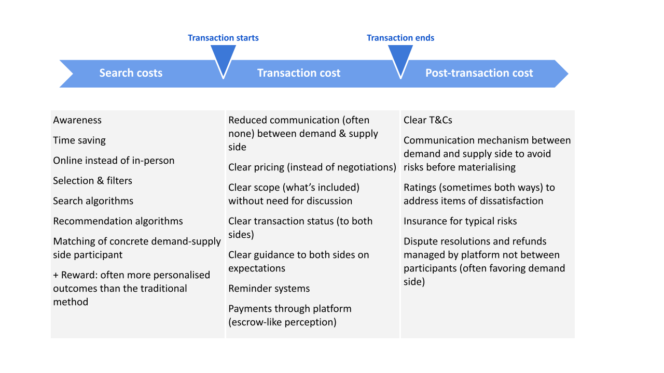

Resource 3: Search & Transaction Cost Examples: Social vertical

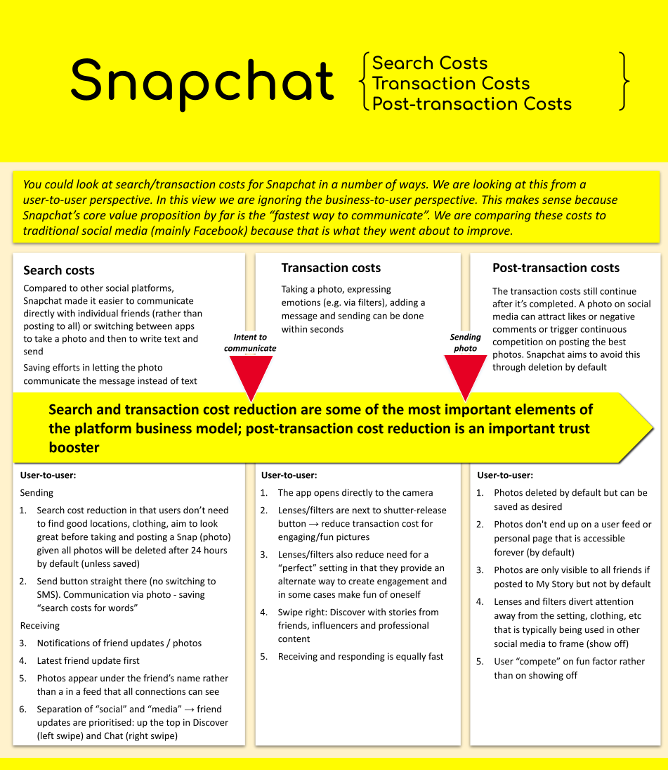

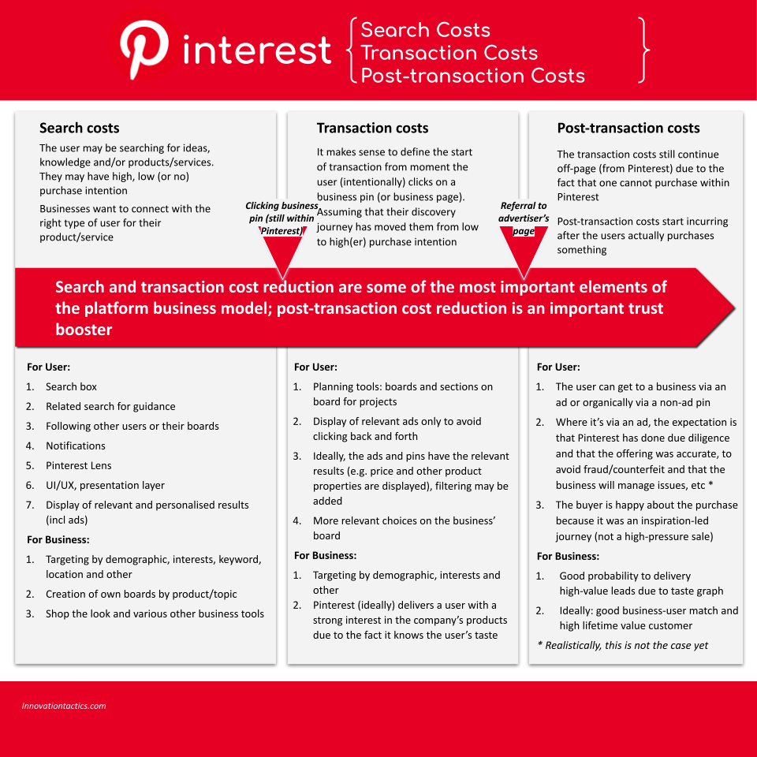

Resource 4: Search & Transaction Cost Examples: Asset & Service sharing
Value propositions
Value propositions to riders

Uber Eats value proposition to consumers

Uber Eats value proposition to consumers

Value proposition to drivers (Uber Rides & Eats)

