Notes & Note taking template
Course - Best Digital Technology Business Models Today
M1.4: Value Chain & Types of Integration

Overview
Value chain tool
The value chain tool is one of the most popular tools to decompose a firm's value creation activities. And we will show that it can also be used for tech firms.
Industry value chains
We can use value chains not only for firms but also to map entire industry value chains. We can compare how competitors are positioned, where profits are made within the industry and more
Types of integration
Industry value chains are great tools to analyse company expansions, mergers & acquisitions which fall under one of the types of integration:
- Horizontal integration
- Vertical integration, including forward and backward integration
This time we will conclude our focus vertical eCommerce and use in-depth examples from the Asset & Service sharing as well as Content & Media verticals.

Key Objectives
With that, the Key Objectives of this submodule are to understand:
- Value Chain tool
- Industry value chains
- Types of integration
  - Horizontal integration
  - Vertical integration
    - Forward integration
    - Backward integration
- Focus verticals
  - Conclude eCommerce with Amazon’s key value propositions
  - Asset & Service Sharing example Airbnb
  - Content & Media example Netflix

Intro / Theory Video

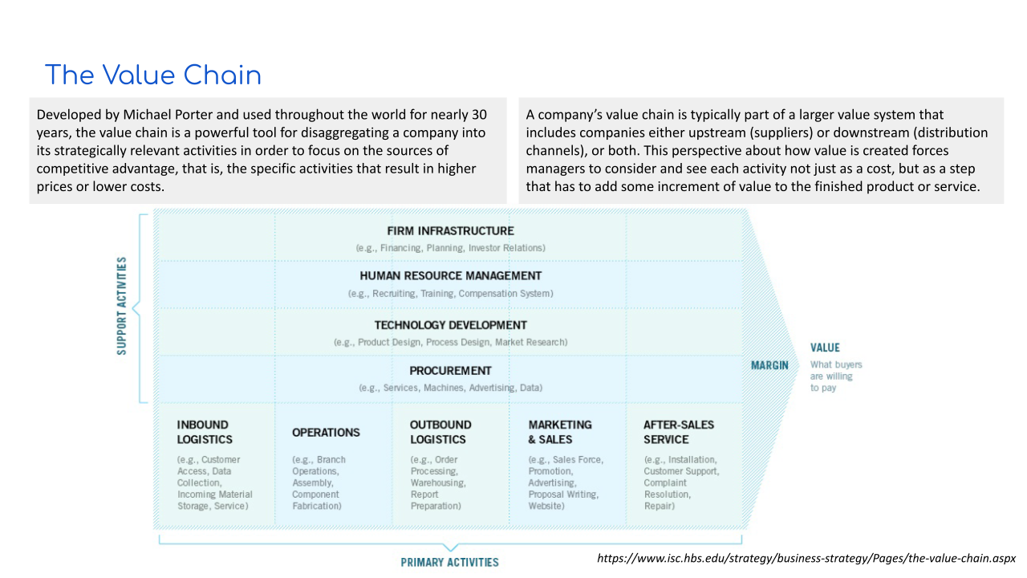

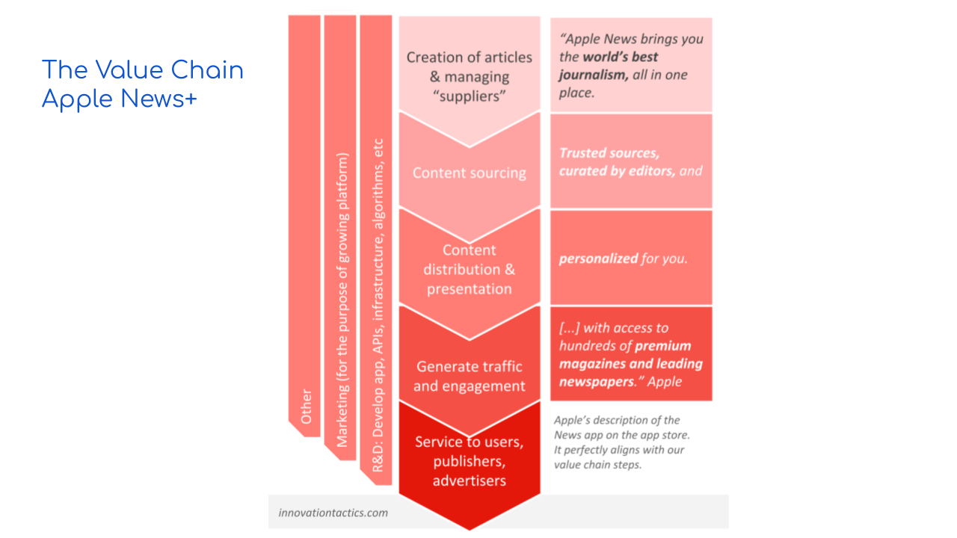

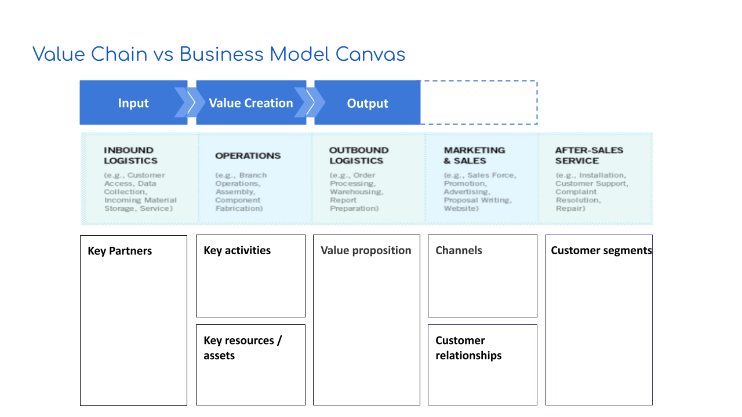

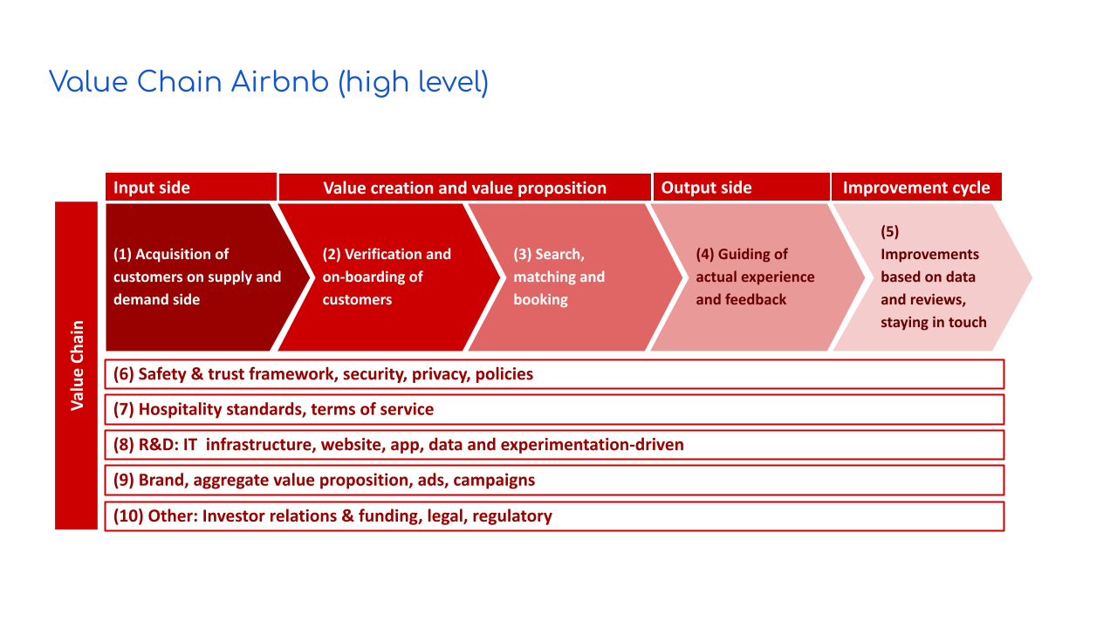

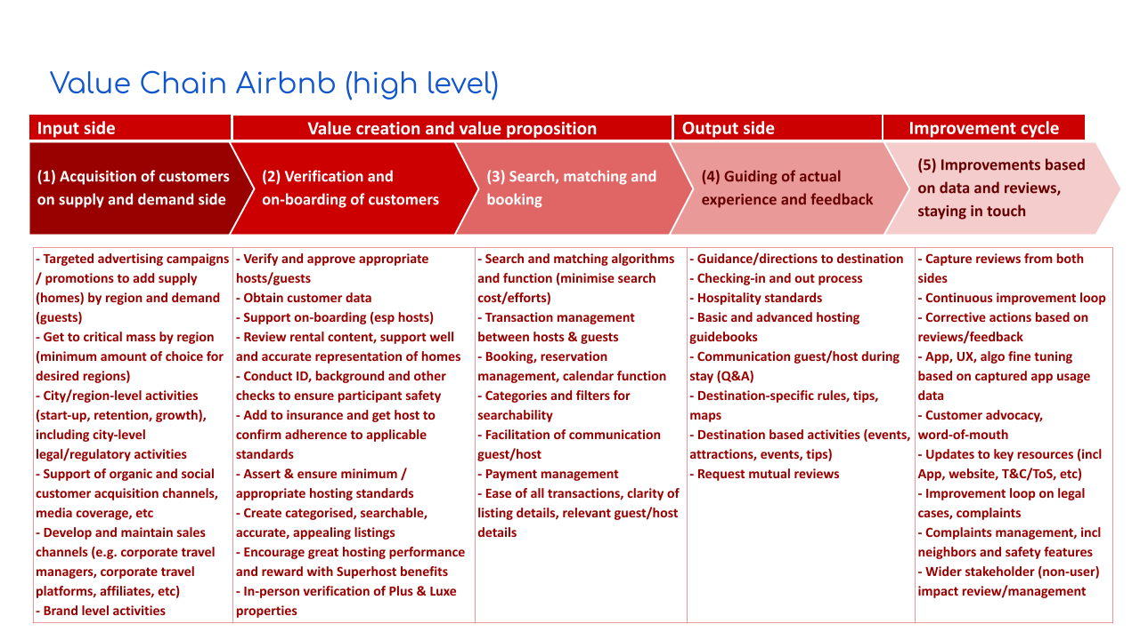

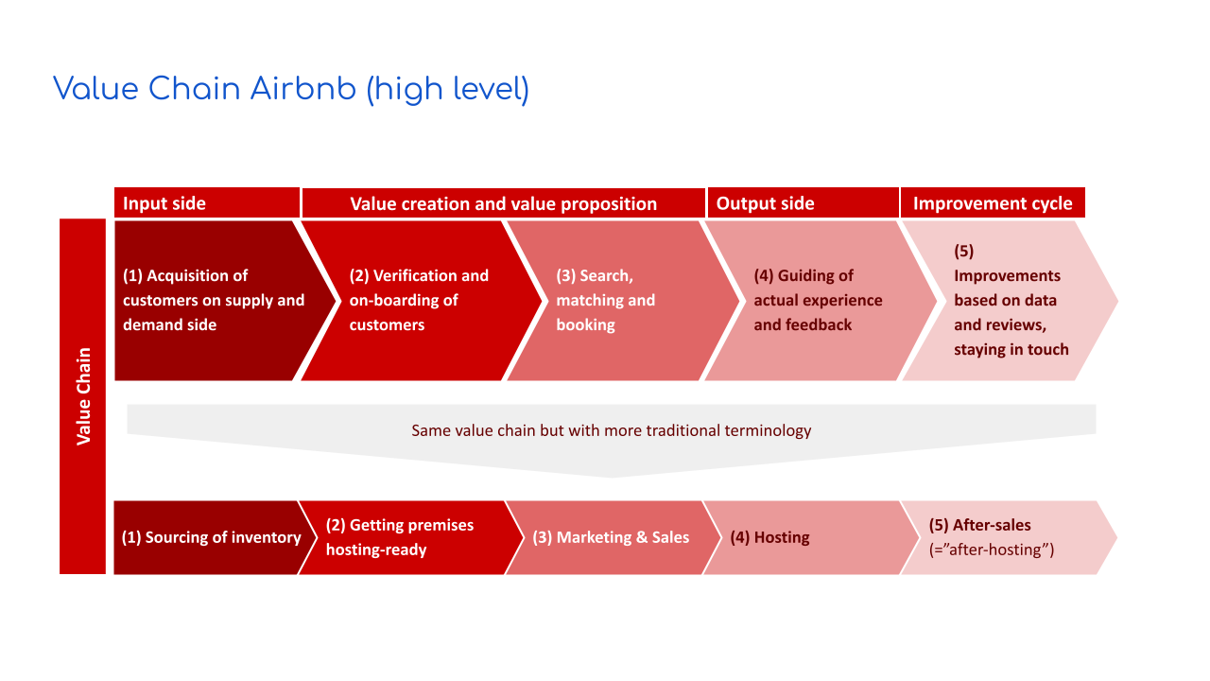

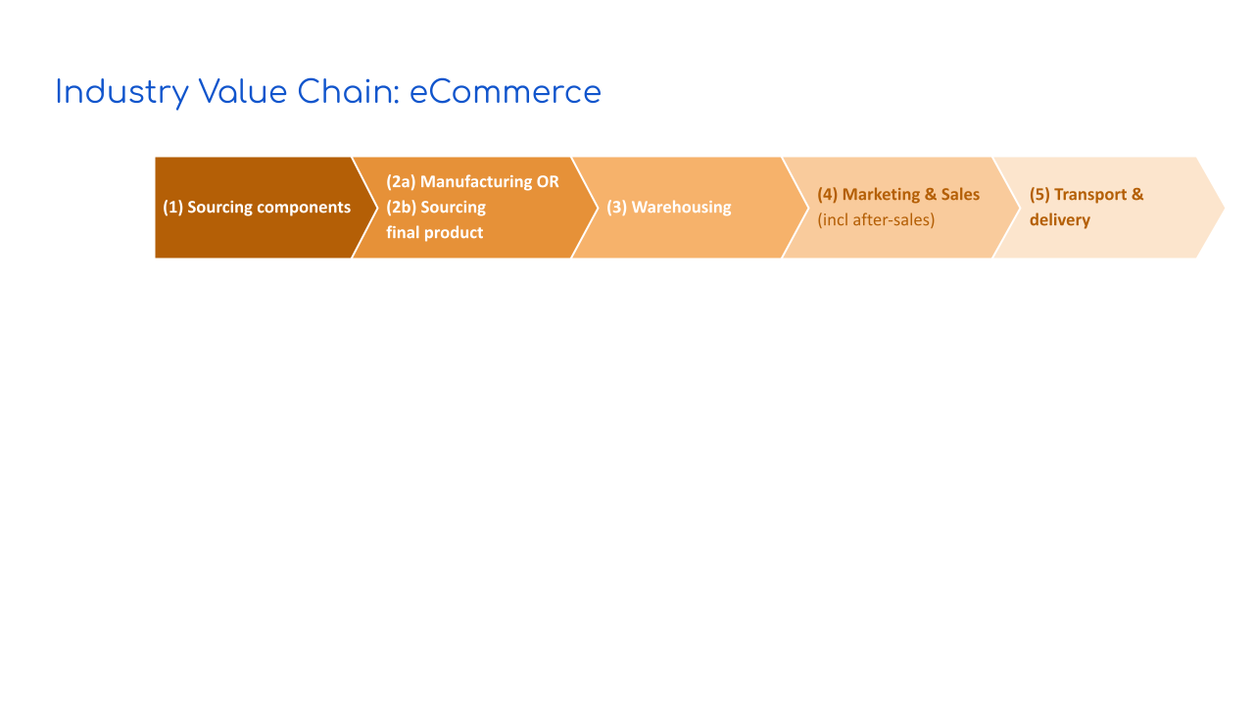

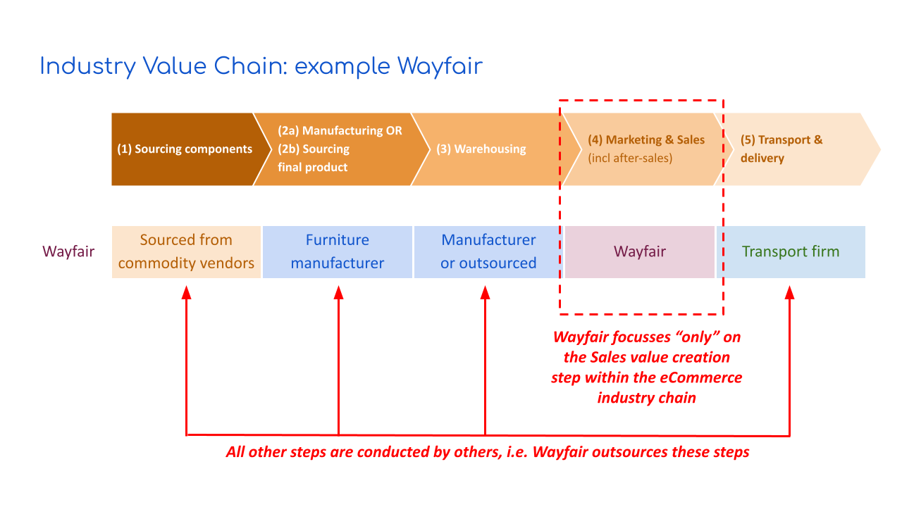

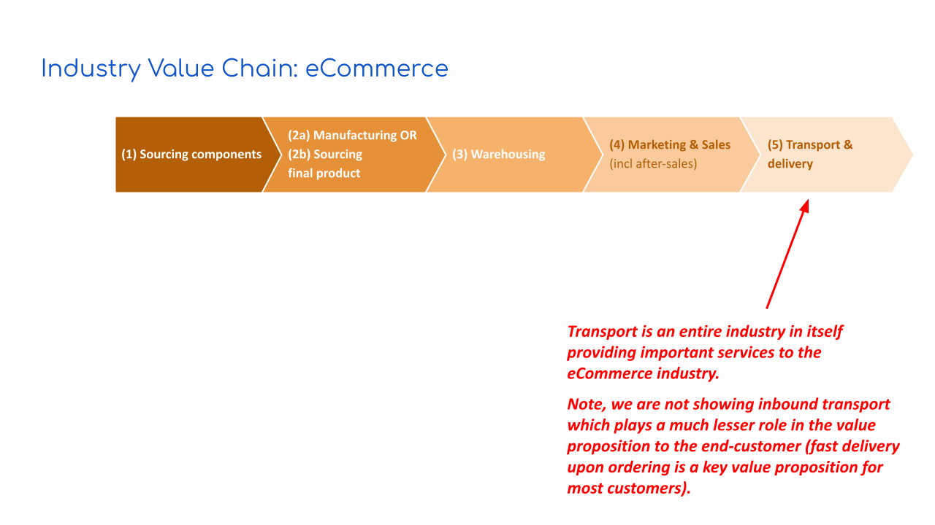

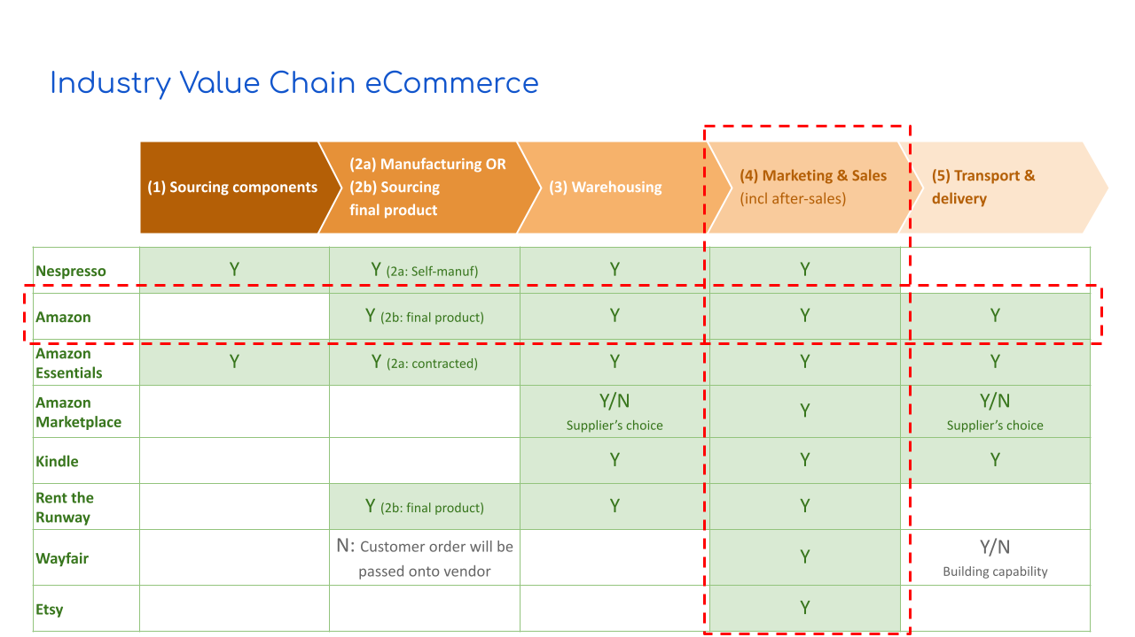

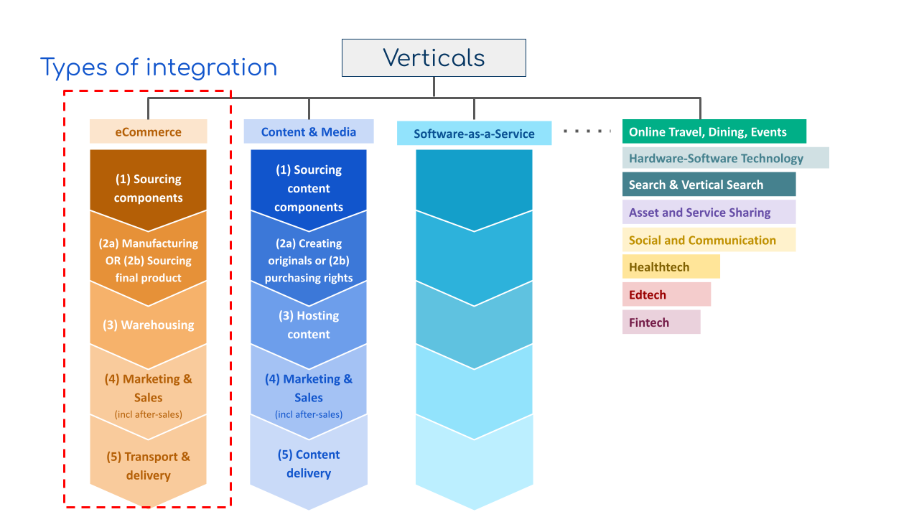

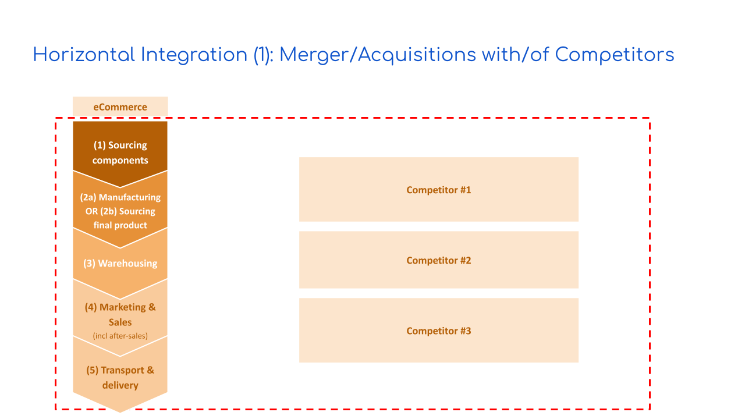

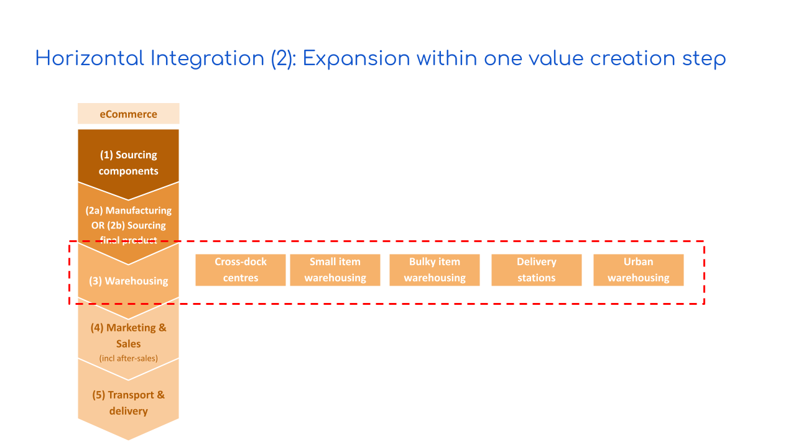

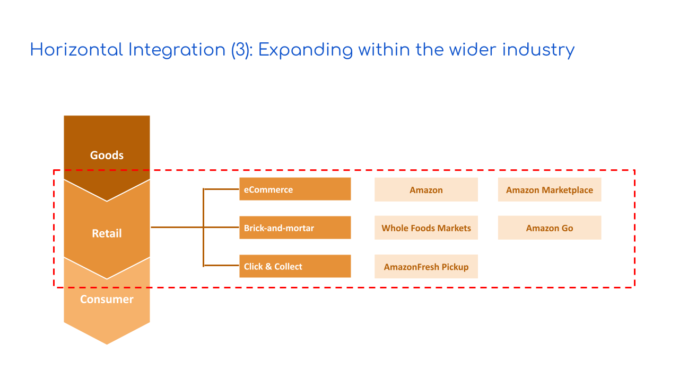

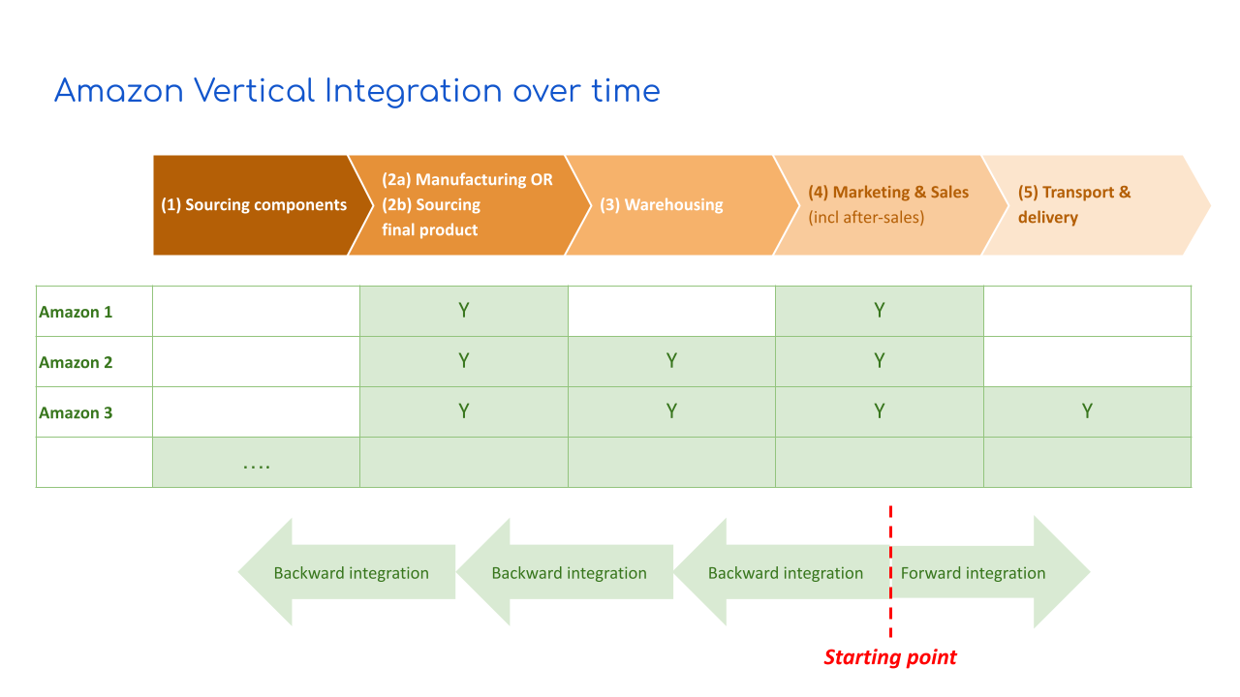

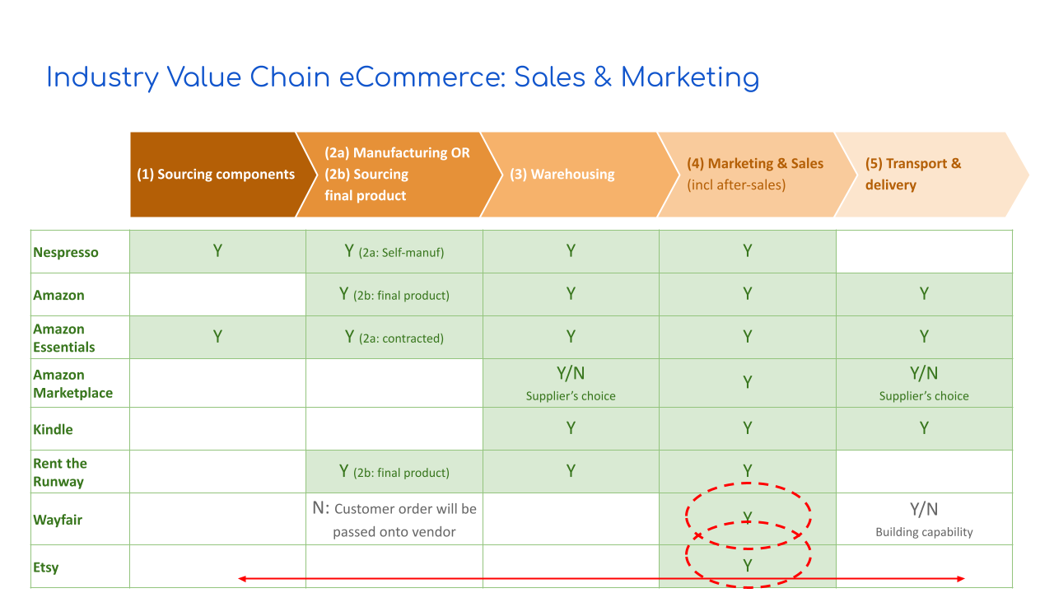

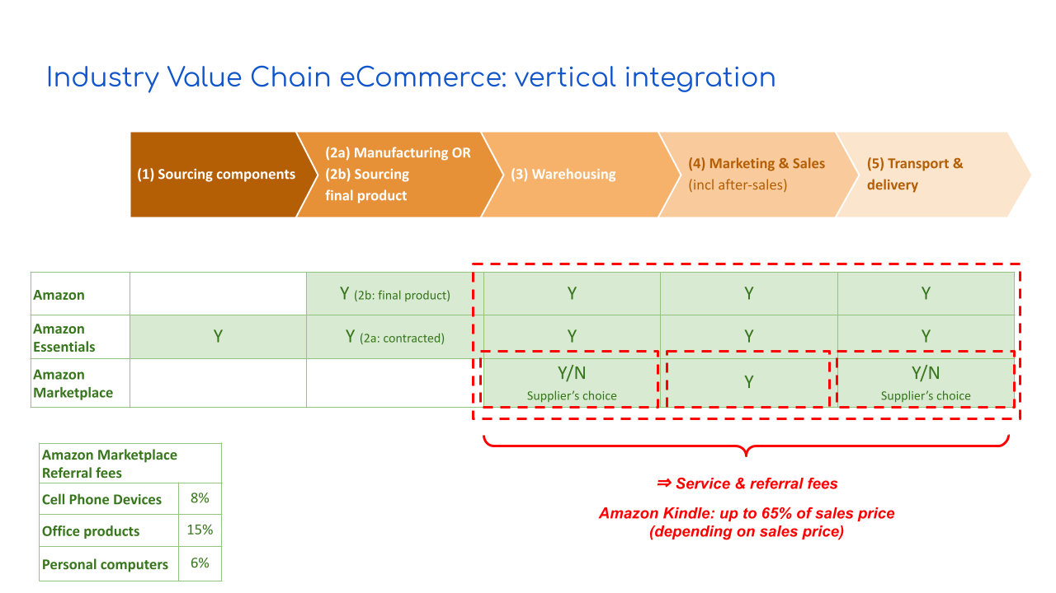

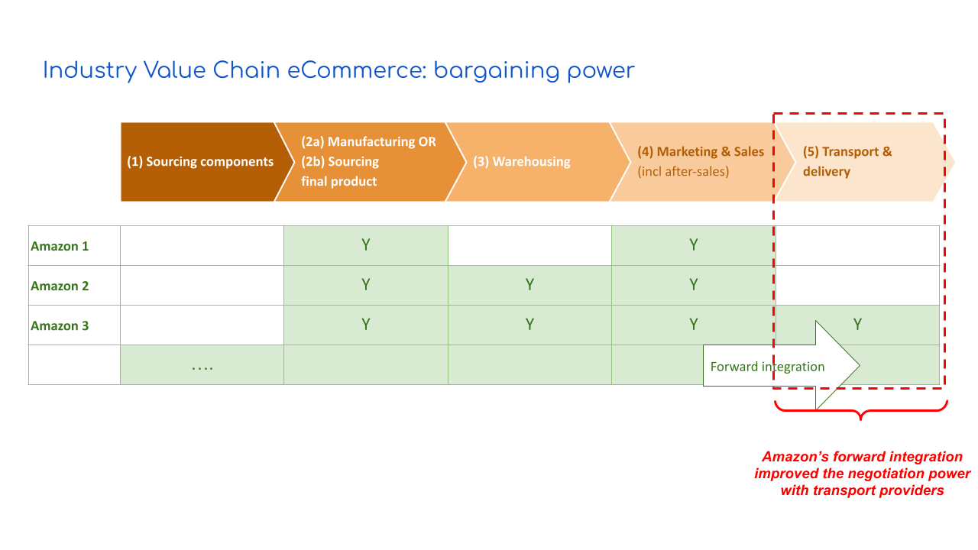

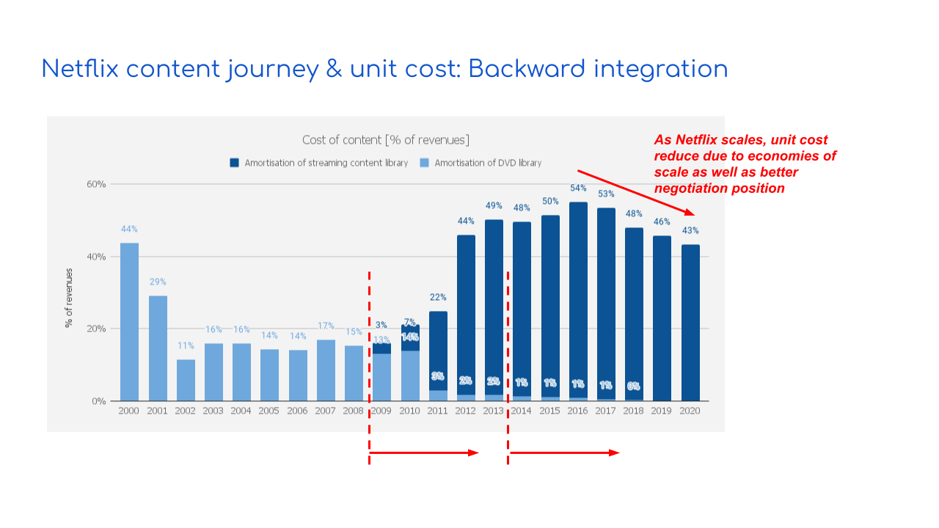

Examples / detailed resources

Resource 1: Apple News+ Value Chain
Contents
The Value Chain
Aggregator apps
Apple News: Monetisation
Value Chain example: Apple News+
- Step 1: Creation of articles & managing “suppliers”
- Step 2: Content sourcing
- Step 3: Content distribution & presentation
- Step 4: Generate traffic and engagement
- Step 5: Service to users, publishers, advertisers
Value creation

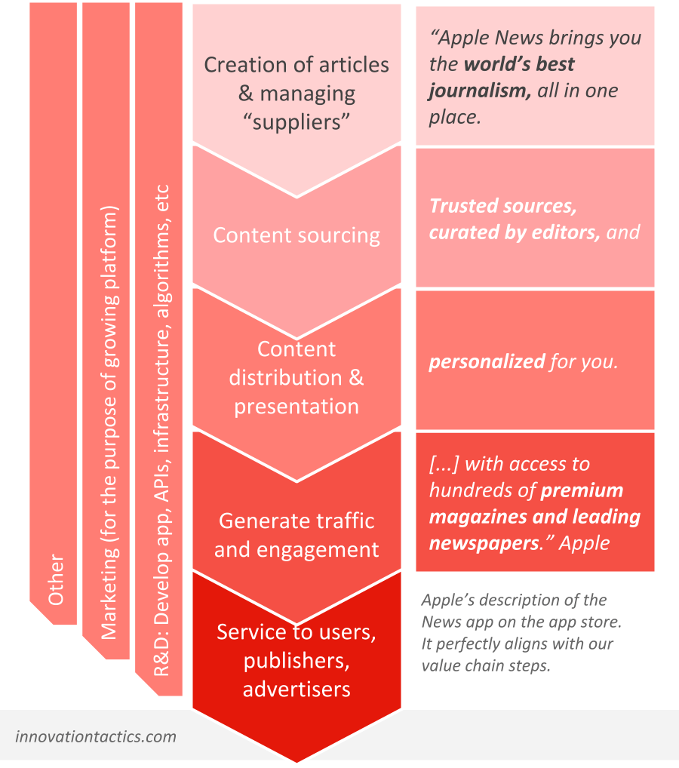

Apple News: Monetisation
Value Chain example: Apple News+
Step 1: Creation of articles & managing “suppliers”
Step 2: Content sourcing
Step 3: Content distribution & presentation
Step 4: Generate traffic and engagement
Step 5: Service to users, publishers, advertisers
Value creation

Resource 2: The Value Chain tool: example Airbnb

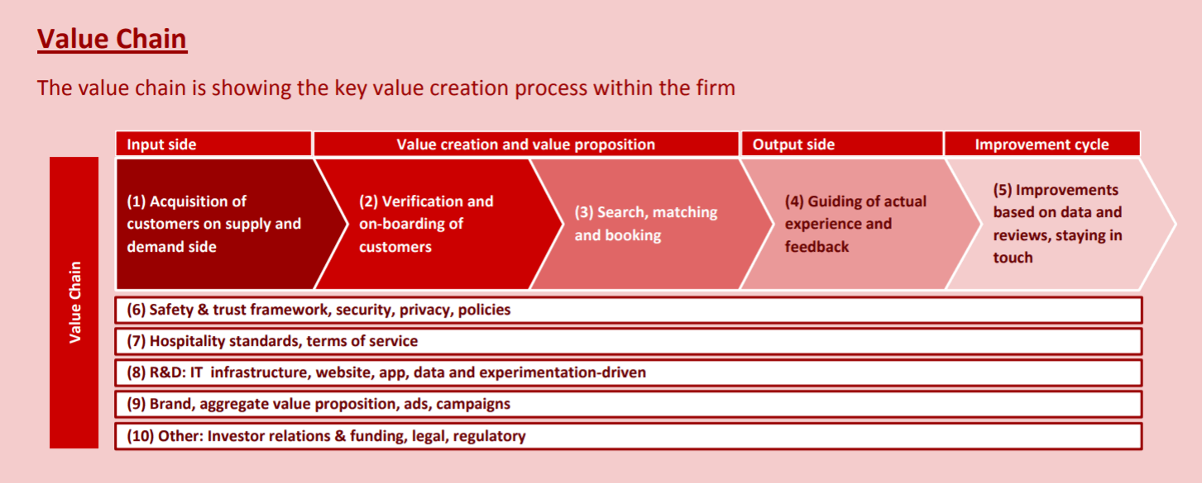

Value Chain steps:
These are the major steps of Airbnb’s value chain.
(1) Acquisition of customers on supply and demand side
(2) Verification and on-boarding of customers
(3) Search, matching and booking
(4) Guiding of actual experience and feedback
(5) Improvements based on data and reviews, staying in touch

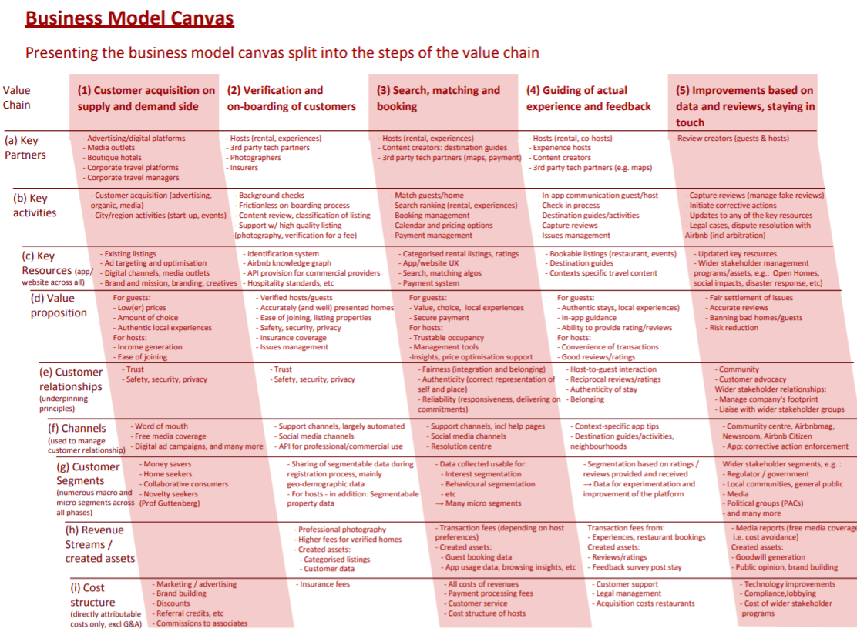

Resource 3: The Value Chain tool (in detail): example Airbnb

Resource 4: Netflix: content journey (over the years)
Contents:
Content costs: Supply chain and commercial economies of scale
- Managing content costs
<2007: Revenue sharing & commercial economies of scale
2007-2010: The big transition
>2010: Building an exclusive streaming content library
>2013: Netflix Originals
>2016: Is there a glut of shows?

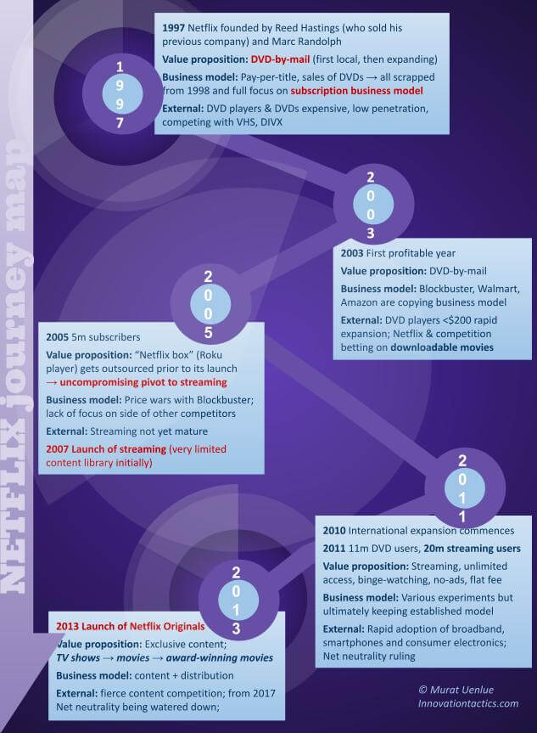

Content costs: Supply chain and commercial economies of scale
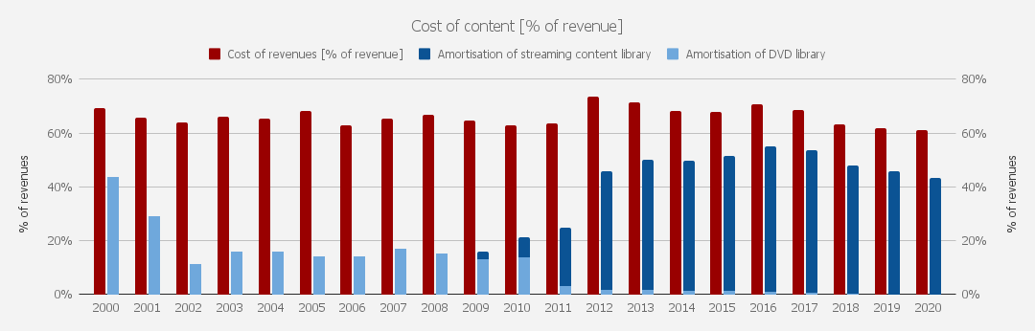

- 1998-2007 DVD-rental-by-mail: Revenue sharing & commercial economies of scale

- 2007-2013 Streaming: 2007-2010: The big transition

- 2013-present Netflix originals: Building an exclusive streaming content library

